Q1) The program must accept a positive integer N and print the digit in the tenth position.

**Input Format:**  
The first line denotes the value of N.

**Output Format:**  
The first line contains the value of N.

**Boundary Conditions:**  
10 <= N <= 9999999

**Example Input/Output 1:**  
Input:  
20

Output:  
2

**Example Input/Output 2:**  
Input:  
37843

Output:  
4

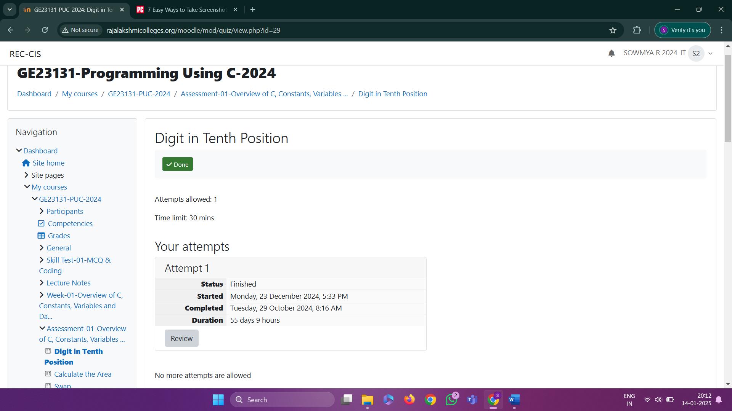

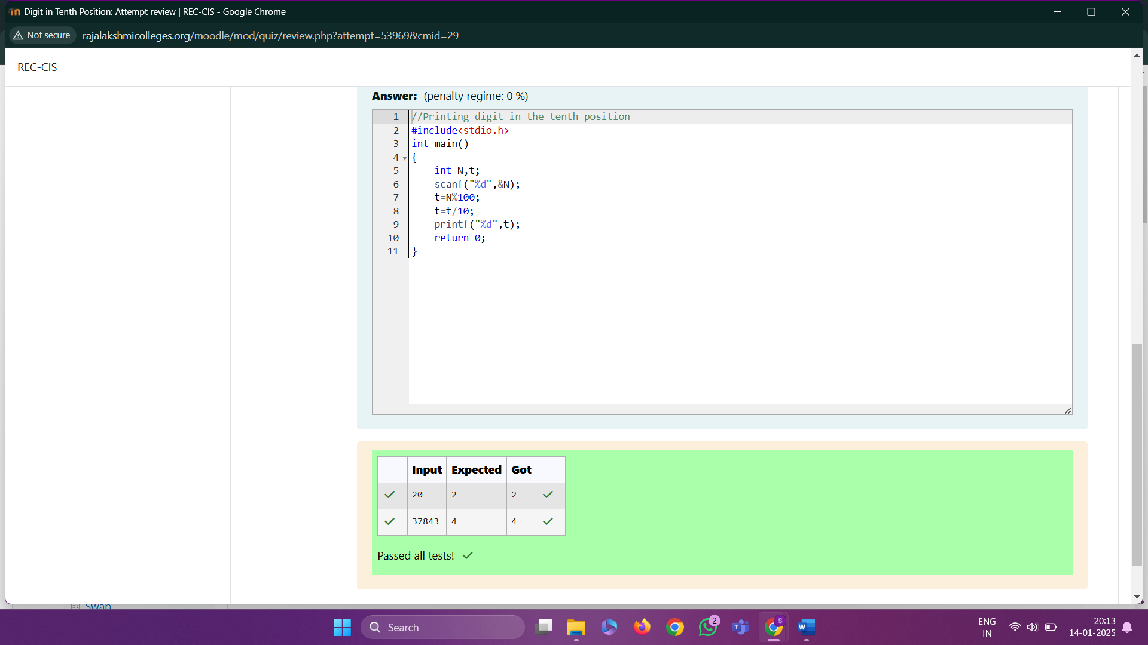

Q2) Write a C Program to calculates the area (floating point number with two decimal places) of a circle given its radius (integer value). The value of Pi is 3.14.

Sample Test Cases

Test Case 1

Input

7

Output

Area of a circle = 153.86

Test Case 2

Input

50

Output

Area of a circle = 7850.00

Test Case 3

Input

42

Output

Area of a circle = 5538.96

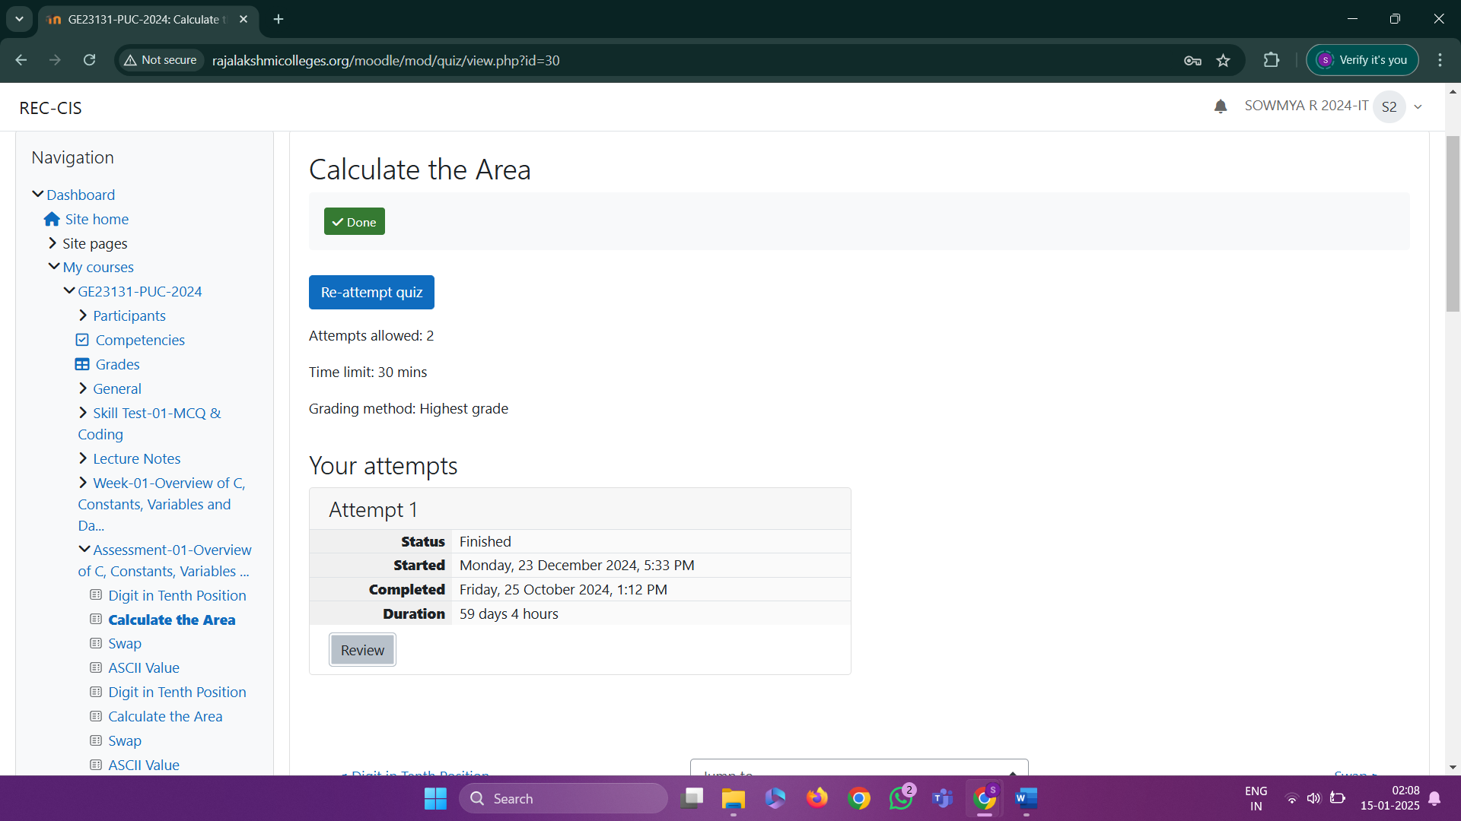

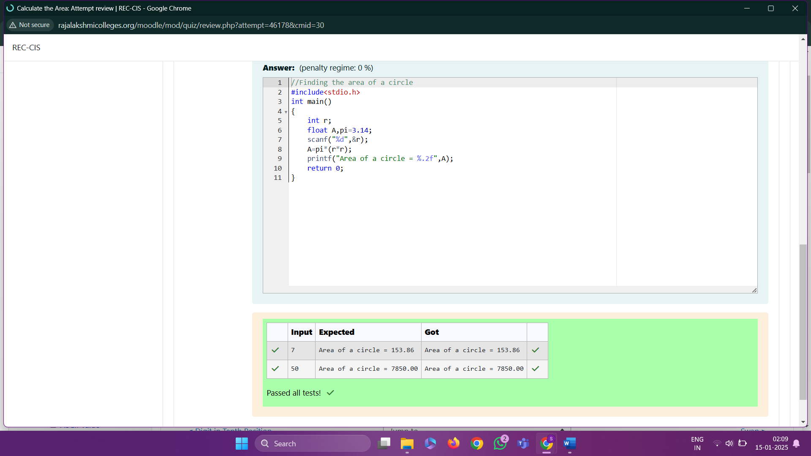

Q3) Swap

Develop a 'C' program to swap two numbers (using three variables).

Input

10 20

Output

Before swapping :

a = 10 b = 20

After swapping :

a = 20 b = 10

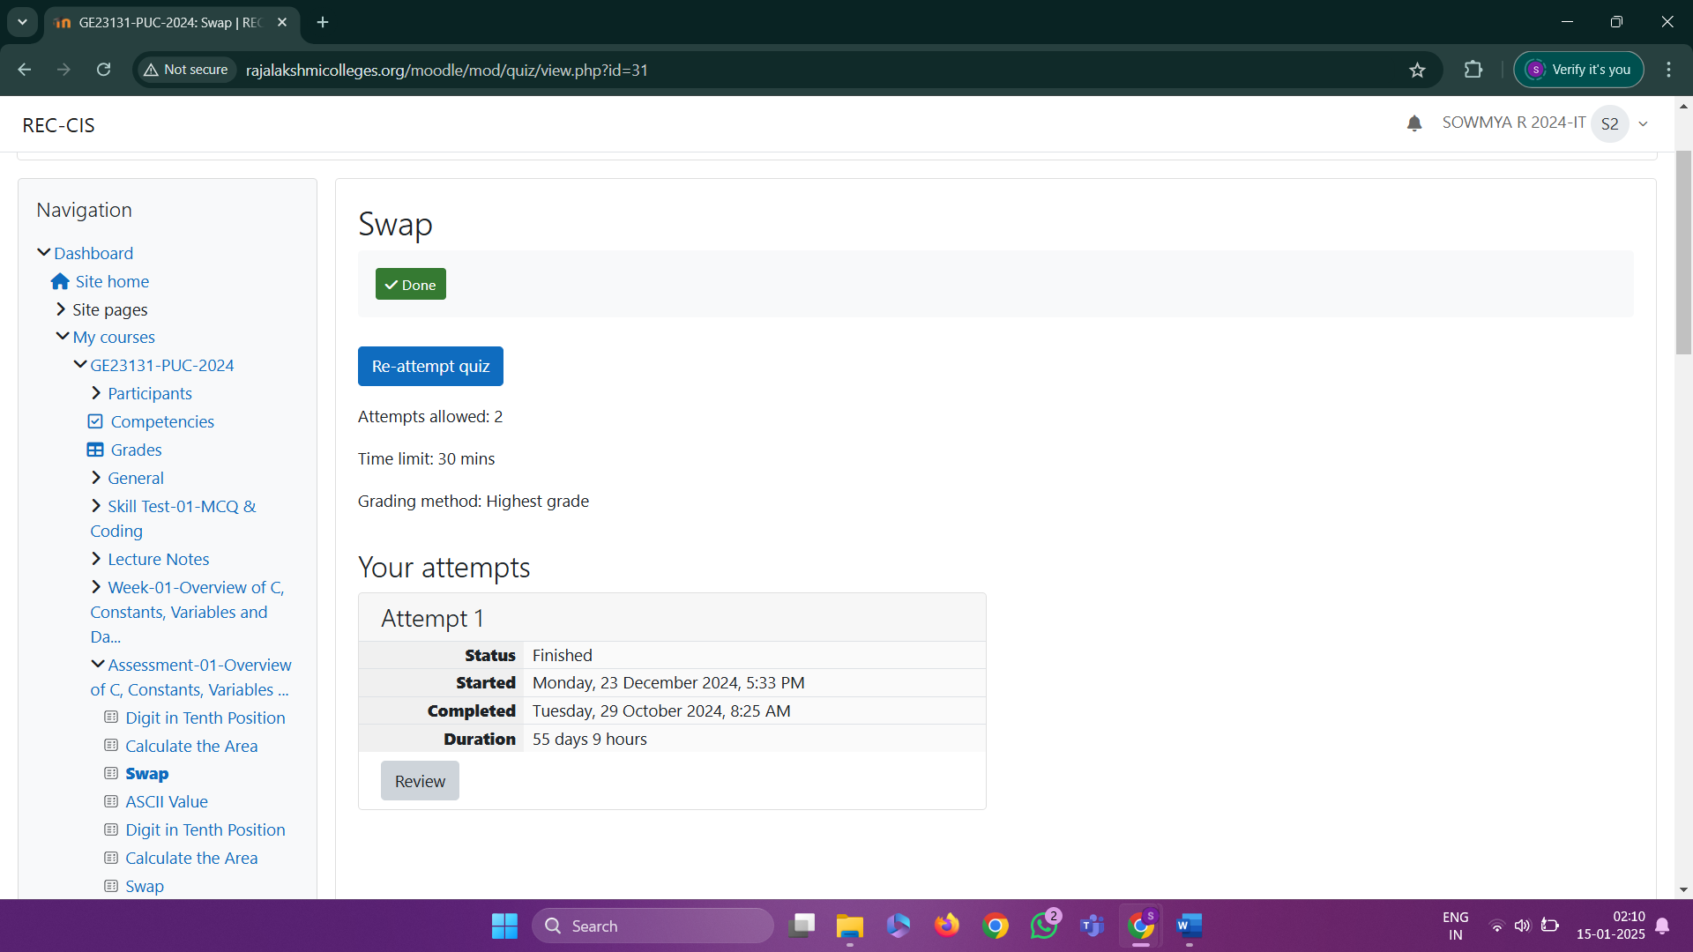

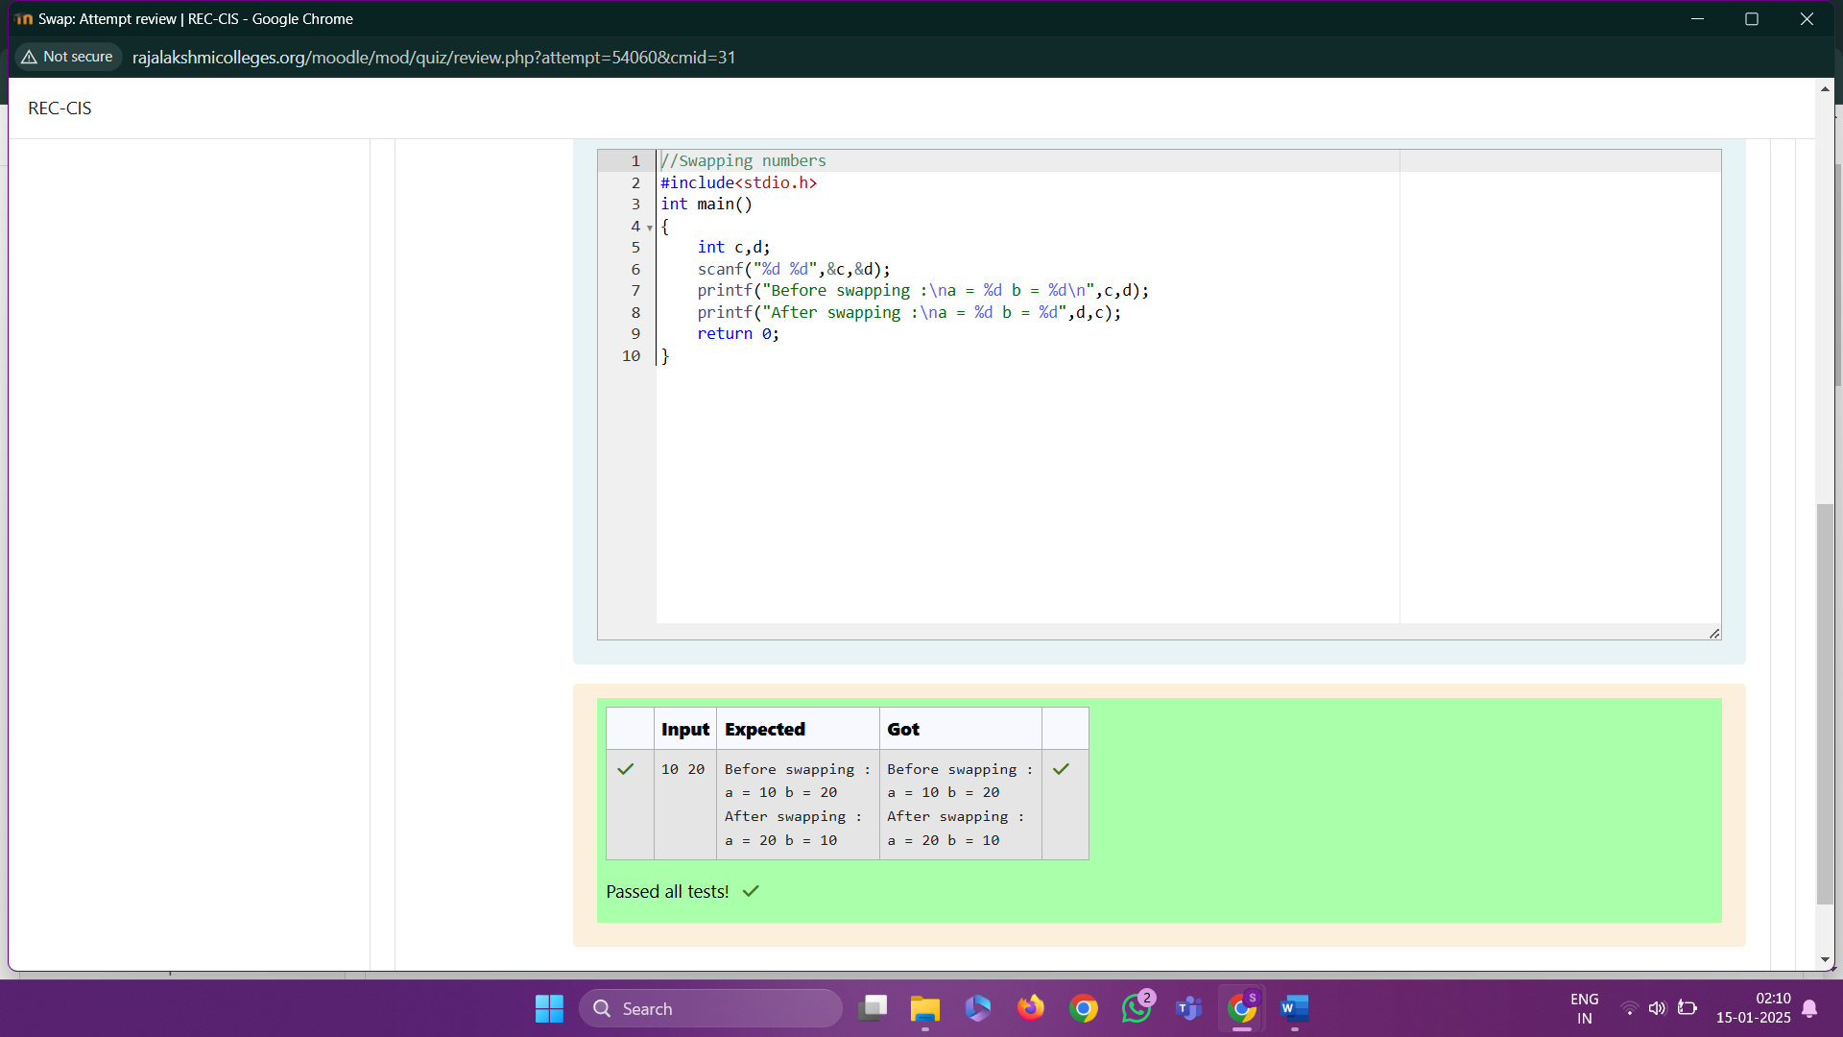

Q4) Write a program to print the ASCII value of the given character.

Input

A

Output

The ASCII value of the given character A is : 65

